Project Design Phase-II
Data Flow Diagram & User Stories

Data Flow Diagrams:
A Data Flow Diagram (DFD) illustrates how data moves within the Freelance Finder platform. It captures how users (freelancers and clients) interact with the system, how information flows between different components, and where the data is stored.
Example: DFD Level 0 (Industry Standard)

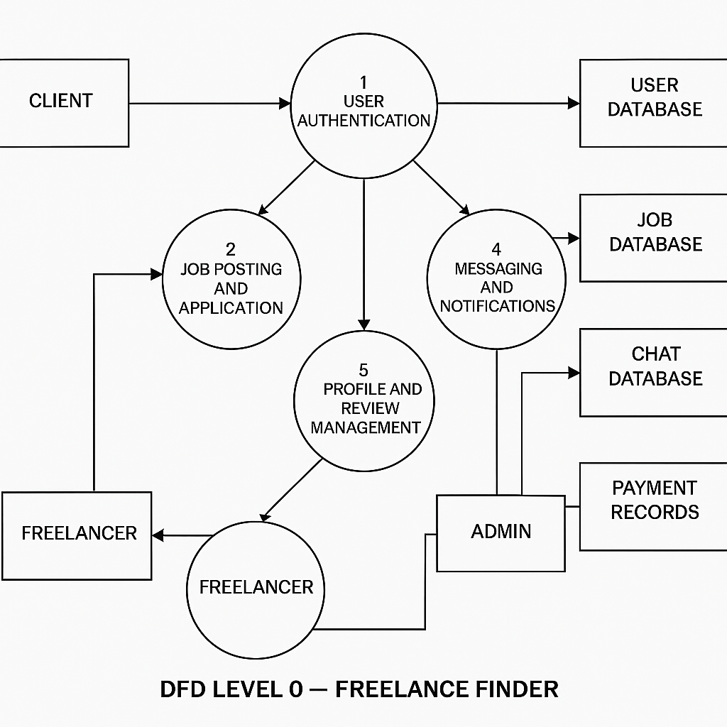

User Stories

User Story Table – Freelance Finder
User Type | Functional Requirement (Epic) | User Story / Task | Acceptance Criteria | Priority | Release
Client |  | As a client, I can post a new freelance job. | Job appears on homepage and my dashboard. | High | Sprint-1
  Job Posting
 |  | As a freelancer, I can browse and filter available job | Filter returns relevant results. | Medium | Sprint-2
  Job Browsing
Freelancer | Job Application |  | Application visible to client. | High | Sprint-1
  As a freelancer, I can apply to a job with a proposal.
User | Messaging | As a user, I can chat with the other party in real-time. | Messages appear instantly. | Medium | Sprint-2
Freelancer | Profile Management | As a freelancer, I can update my profile and portfolio. | Changes are saved successfully. | High | Sprint-2
Client | Payment Processing | As a client, I can make secure payments after job completion. | Payment recorded and shown in transaction history. | High | Sprint-2
user |  | As a user, I can leave a review after project closure. | Review appears on profile. | Medium | Sprint-2
  Review System
Admin | User Moderation | As an admin, I can review reported users and take action. | Reports and actions logged. | High | Sprint-1

